**GENERAL INSTRUCTION FOR PAPER AUTHORS**

The full paper consist of **4000-5000** **words** (including abstract, references).

Please use **SINGLE SPACE.**

Please use the font of **Times New Roman, size** of **12,** paper size is A4 (210 x 297) with margin (1x1x1 inches).

Please be consistent in the CITATION format.

**Below is the template of the full paper**

**International conference of Social and Political Issues on Sustainable Development in Post Covid-19 Crisis**

**Click here, type the tittle of your paper, Capitalize each word (Times New Roman, bold, 14 pt)**

First Authora, Second Authorb, Third Authorc

(written without an academic degree, Times New Roman, 12pt)

*aFirst affiliation, Address, City, Country* (Times New Roman, 12pt)

*bFirst affiliation, Address, City, Country* (Times New Roman, 12pt)

*cFirst affiliation, Address, City, Country* (Times New Roman, 12pt)

*Coresponden* Author : email

**Abstract**

In this section, insert your abstract text at least 90 word until 250 word maximum. Font is Times New Roman, 10 pt. Abstract must contain reseach objectives, methods, result or findings, conclusion and limitation (optional).

*Keywords*: Type your keywords here.

**The content of manuscript must be contained Introduction, Methodology, Results & Discussions, and Conclusion.**

**Introduction**

Should contain (shortly and consecutively) a general background and a literature review (state of the art) as the basic of the brand new research question, statements of the brand new scientific article, main research problems, and the hypothesis. In the final part of the introduction, the purpose of the article writing should be stated.

**Methodology**

explains how the research is conducted, including research design, data collection, research instrument and analytic methods as well as reliability and validity of findings. This part should be narrated

**Results and Discussions**

This part consists of the research results and researchers is discussed. The results obtained from the research have to be supported by sufficient data. The research results and the discovery must be the answers or the research hypothesis or research question stated previously in the introduction part

**Conclusion**

This is the final part containing conclusions, limitations and recommendations. The conclusions will be the answers of the hypothesis or research question, the research purposes and the research discoveries. The conclusions should not contain only the repetition of the results and discussions. It should be the summary of the research results as the author expects in the research purposes or the hypothesis. Research limitations and recommendations contain deficiency in the research and suggestions associated with further ideas from the research.

## **Figure and Table**

.

Here the example how the table look like:

**Table 1**. Title of table

**Table 1.** The Case of Violence Against Women and Children

|  |  |  |  |
| --- | --- | --- | --- |
| **No** | **Years** | **case of Violence Against Women and Children** | **Case of Domestic Violence** |
| 1 | 2013 | 45 | 85 |
| 2 | 2014 | 29 | 56 |
| 3 | 2015 | 53 | 58 |

Source: BPS (Statistitical Agency, 2019)

*Source*:.......

If you use picture, it should look like:

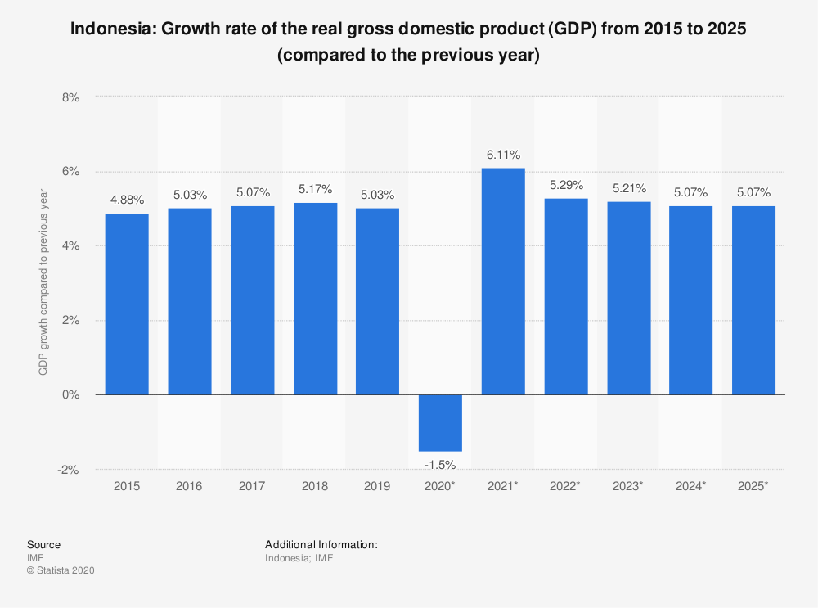

**Picture 1**. Indonesia GDP Growth Rate Compared

*Source*: International Moneter Found (2020)

# References

When using APA format, follow the author-date method of in text citation.

Examples:

**(a) Books**

: Anglin, R. V. (2010). *Promoting Sustainable Local and Community Economic Development*. London: CRC Press

**(b) Journal Article**

Juswil, A., & Nofrima, S. (2020). Government Social Media Existence: Case Study on the Use of Twitter Regional Disaster Management Agency, Province of Yogyakarta Special Region). Journal of Local Government Issues (LOGOS), 3(2), 98-110. doi:<https://doi.org/10.22219/logos.v3i2.12113>

**(c) Chapters in edited books**

Evans, T. (1997). Democratization and Human Rights, In A. McGrew (Ed.), *The transformation of democracy?* (pp. 122-148). Cambridge: Polity Press.

**(d) Conference Paper/Proceeding**

# Mursidi, R. Iqbal Robbie. (2019, October). *Morning Spiritual Gathering (MSG) Leadership: A New Leadership Style?.* . Proceedings of the 6th International Conference on Community Development (ICCD 2019). 369-372. <https://dx.doi.org/10.2991/iccd-19.2019.97>

**(e) Research Report**

Roziqin, Ali. (2019). *Dinamika Pengembangan Batik Tulis Lasem di Era Disruption* (Magister Thesis). University of Gadjah Mada.

**Magazine:**

Example: Tumulty, K. (2006, April). Should they stay or should they go? Time, 167(15), 3-40.

**Online Magazine:**

Example: Tumulty, K. (2006, April). Should they stay or should they go? Time, 167(15) Retrieve from http://content.time.com/time/magazine/article/0,9171,1179361,00.html

**Online Newspaper**:

Example: Rosenberg, G. (1997, March 31). Electronic discovery proves an effective legal

weapon. *The New York Times,* Retrieved from <http://www.nytimes.com>

**Website**:

Devi, Ratia. (2020). Menilik Potensi Resesi Ekonomi Indonesia di Tengah Pandemi Covid-19. Retrieved December 19, 2020, from <https://www.kompas.com/tren/read/2020/08/07/090500665/menilik-potensi-resesi-ekonomi-indonesia-di-tengah-pandemi-covid-19-?page=all>.